26.19: a) 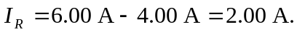
b) Using a Kirchhoff loop around the outside of the circuit:
c) Using a counterclockwise loop in the bottom half of the circuit:
d) If the circuit is broken at point x, then the current in the 28 V battery is:
